Monroe Country Club, Inc.

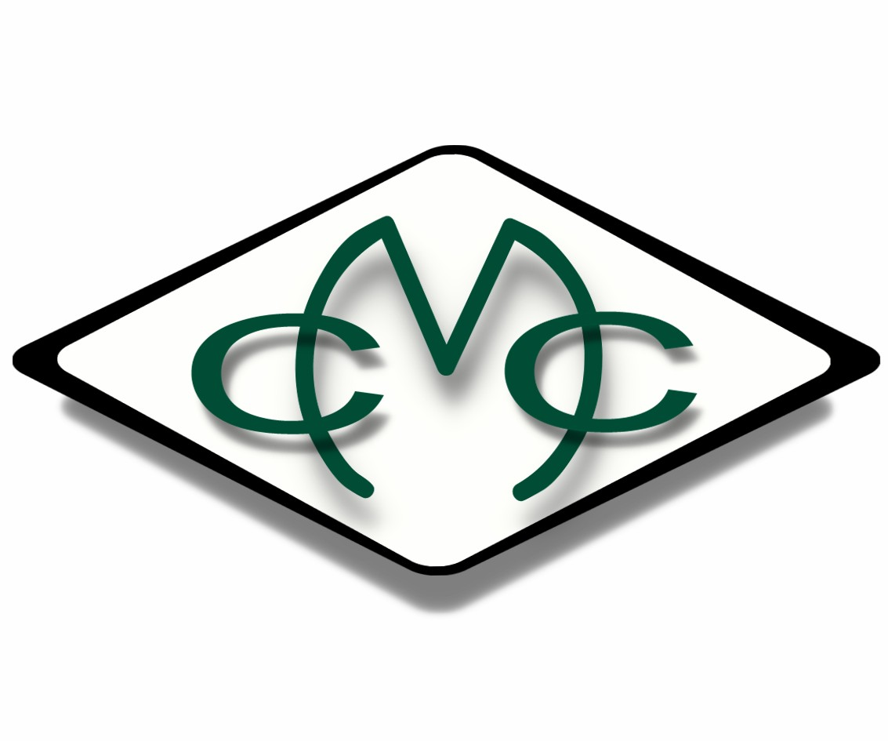
2017 Membership Package for New Members

Monroe Country Club

63 Still Road, Monroe, New York 10950-3999 (845) 783-9045

www.monroecountryclubny.com

1

Monroe Country Club
63 Still Road Monroe, New York 10950

Letter to Prospective Members – 2017

You are cordially invited to become a member of Monroe Country Club (MCC) in Monroe, New York. MCC is collectively owned by its “A” (equity) members and the goal of the Club is to provide a rewarding golf experience for members and guests and a pleasant social experience for all.

WHY JOIN MONROE COUNTRY CLUB?
You enjoy playing golf. You enjoy a challenge. You would like little to no waiting time to tee off. You like a pleasing social atmosphere… Then come join us! Take a look at our membership package, and even drop by and view our facilities. We would like to welcome you to the pleasant, social golfing experience at Monroe Country Club.

THE PRICE IS RIGHT – NEW MEMBERSHIP DRIVE PACKAGE AVAILABLE (some restrictions apply, see page 3). MCC has embarked on an aggressive plan to increase members through a special discounted membership package for "new" members. An Individual Non Equity class membership is now $750 per year; Husband/Wife is $1150; Family is $1400; and Junior (23 yrs old or less) is $350. These memberships entitle you to play as many rounds of golf as you please and include access to our pre-arranged tournaments and social events. There are no ownership nor voting rights included in this package, and no bond or restaurant/bar tab minimum is required.

Our golf season begins when the course is playable in the Spring, and continues into the Fall until the weather is too cold for play.

From April through October, there are 65 weekend days and holidays. As a new member, if you play just once per weekend for all those days, your greens fees, as a non-member, would well exceed the membership rate. The New Non Equity membership allows you unlimited play any day of the week. REMEMBER, greens fees are included in the membership fee.

THE TIME IS RIGHT:

Prime play time is Saturdays, Sundays and holidays. Members are given preference for tee times before 12:00 noon on those days.
Although the course is never really crowded, the idea is to limit non-members from using the course during these hours of prime play, so that members of MCC can enjoy a sense of privacy during these hours and reduce the amount of crowding on the course.

RIDING CARTS AND GREENS FEES:
We have golf riding carts available for rental by golfers who prefer to ride rather than walk. However, we DO NOT REQUIRE golfers to ride carts. There are still many MCC golfers who prefer the exercise of walking. If you like to ride, members pay reduced rental rates.

2

Monroe Country Club
63 Still Road Monroe, New York 10950

2017 Membership Program

Monroe Country Club is offering this new, highly competitive membership option that can fit almost any budget. (Former members may be restricted from discounted introductory memberships--see restrictions below). This membership is also non-transferable.
This Non-Equity Membership is only for new members of Monroe Country Club.
Monroe Country Club is owned by its Equity Members. The latter share in the ownership of the Golf Club and post a bond. They additionally have voting rights regarding Club business and can serve as Board members, if elected. Non-Equity members do not share in ownership of the club, have no voting privileges and cannot serve as a Board member. However, Non-Equity Members are not required to post a bond nor are they required to fulfill an annual restaurant/bar tab.

RESTRICTIONS:

Former members of Monroe Country Club are restricted from all new Non-Equity memberships for a period of 5 years from cancellation of their previous membership.

3

Monroe Country Club
63 Still Road Monroe, New York 10950

GOLF ATTIRE:
Monroe Country Club has a dress code and requests that members and guests follow these guidelines: for men, no gym type shorts, “cut-off shorts” or sleeveless shirts, and for ladies no short- shorts or halter tops. Proper golf attire required at all times. (See page 6 – Course Rules)

GOLF ETIQUETTE:
Slow players should generally invite a faster following group to play-through if there are one or more open holes ahead. Also, in order to maintain the quality of our greens, you are requested to repair your ball marks and rake sand traps.

GUESTS:
Members that bring guests during prime play time must have the guest play in the same foursome as the member- host. All guests should be registered and pay the greens fee in the Pro-shop prior to play. (Prime time is on weekends and holidays prior to 12:00 noon)

ALCOHOLIC BEVERAGES:
Because of legal restrictions the club requests that no beer, liquor or other alcoholic beverage be taken onto the course. Beverages are available in the Clubhouse and the deck area provides a pleasant location to view the course and socialize with friends.

OUR COURSE:
The MCC course is a nine-hole layout with regular tees generally being in different locations giving the back 9 holes a different look and feel from the front 9 layout. The course is challenging and not easy to beat as most low handicappers find out the first time they play. Thanks to the efforts of our Grounds Superintendent and Staff, the course is always in excellent condition.

FACILITIES:
The Club House contains full restaurant and bar facilities leased to and managed by “Birchwood Caterers”.

PRO-SHOP:
The MCC Pro Shop carries commonly used golf supplies (balls, tees, gloves, shirts, hats, towels, etc.). The Pro Shop can facilitate club repairs such as grips and shafts, as well as ordering of complete sets of clubs, bags, and shoes.

NO METAL PENETRATING SPIKES ARE ALLOWED:
In order to preserve the greens, all players are requested to wear soft spikes only.

4

SOCIAL EVENTS:
The entertainment committee has prepared, for MCC members, a list of special events, including parties and socials. All social events have a modest fee.
GOLF TOURNAMENTS:
The tournament committee has a variety of golfing tournaments scheduled for members only during the season. The outings are both competitive and fun and most are set up to allow high and low handicap golfers to compete equally against each other. The idea is to get members competing with other members with whom they might not regularly play.
OFFICIAL MGA HANDICAP:
MCC is a member of the Metropolitan Golf Association (MGA), which prepares regular updates of the player’s handicaps. After each round, members turn in their score. These scores are sent by computer to the MGA (Metropolitan Golf Association) office where the handicaps are computed, and a printout of member handicaps is prepared for the club. Each member receives an official MGA Handicap Card with updated handicaps. This service is provided to members of MCC for an annual fee of $40. These handicaps can be used when visiting other clubs, and for local tournaments.
GOLF LOTTERY:
We have a weekend and holiday lottery for members. Just show up at a prescribed time (usually 8:00AM) and you will be teamed up with other members for a round of golf. This continues to be a success and provides an opportunity to play with other members with whom you might not regularly play and to play with others when you come to the course alone.

MONTHLY LOTTERY DRAWING:
The Club needs to be financially supported by its members and guests for ongoing operations and future improvement. This support comes in a variety of ways such as daily public greens fees, cart fees, membership dues, sponsored events and any additional assessments for operations and improvements as determined by the Board of Governors. Additionally the Club holds a monthly 50/50 lottery drawing from April through November. Each Non Equity member will be billed $20 for each of the above listed months and posted to their club bill; they will then be entered in this monthly drawing.

2017 COURSE RULES

- GOLF SHOES WITH METAL PENETRATING SPIKES ARE NOT PERMITTED ON THE COURSE.

- EVERYONE WILL START ON THE FIRST HOLE, UNLESS DIRECTED TO START ON ANOTHER HOLE BY THE PRO-SHOP.

- SINGLES AND TWOSOMES WILL BE MATCHED UP WITH OTHER GROUPS IN ORDER TO SPEED UP PLAY. SLOWER PLAYING GROUPS MUST INVITE A FASTER FOLLOWING GROUP TO PLAY THROUGH IF THERE ARE ONE OR MORE OPEN HOLES AHEAD.

- PROPER ATTIRE IS REQUIRED AT ALL TIMES. THIS INCLUDES:
  - APPROPRIATE GOLF ATTIRE
  - NO CUT-OFF SHORTS, FATIGUE PANTS, TANK TOPS, T-SHIRTS, TORN CLOTHING, ETC.
  - SLACKS, SHORTS, SKIRTS, GOLF SHIRTS, AND SWEATERS FOR LADIES.
  - NO HALTER TOPS, SHORT SHORTS, SWIMSUITS, ETC.

- NO PERSONAL COOLERS WILL BE PERMITTED ON THE COURSE.

- GROUPS COMPLETING PLAY ON THE 9TH HOLE WILL HAVE PRIORITY ON THE 10TH TEE.

- ALL RENTERS/OPERATORS OF GOLF RIDING CARTS MUST POSSESS A VALID DRIVER’S LICENSE AND BE AT LEAST 18 YEARS OF AGE.

- NON-PLAYERS ARE NOT ALLOWED ON THE COURSE AT ANY TIME, AND ALL PLAYERS MUST HAVE THEIR OWN SET OF CLUBS.

- ALL QUESTIONS, COMMENTS, OR CONCERNS ABOUT GOLF COURSE RULES AND/OR OPERATIONS SHOULD BE DIRECTED TO THE APPROPRIATE BOARD MEMBER OR SUBMITTED IN WRITING TO THE BOARD.

- “C” & “D” MEMBERS WILL NOT TEE OFF PRIOR TO 12:00 PM ON WEEKENDS AND HOLIDAYS, UNLESS THEY ARE PLAYING WITH AN “A” OR “B” MEMBER IN THEIR GROUP.

- VIOLATIONS OF ANY OF THESE RULES COULD RESULT IN YOUR BEING ASKED TO LEAVE THE COURSE, OR OTHER SANCTIONS.

2017 Membership Application

Name Address City, State

ZIP

Home Phone(
Date

)

Date of Birth Employer Business Street Business City, State
(Applies to A-1, Senior, C, D & F Members) Occupation
ZIP

Business Phone ( ) Email address
Home Phone ( )
Cell ( )

Please list personal information (prior club affiliations, golf experience, organization or information helpful to the Membership Committee).

If accepted, I agree to abide by the house and ground rules and regulations of Monroe Country Club, Inc.
Member Class Yearly Fee MGA Handicapping Fee Total Dues Payment
Bond Payment
 | Additional Names | Member Class | Date of Birth | Yearly Fee | MGA  Handicap Fee ($35)
1)
2)
3)
4)
Total Dues Accompanying Application: $

Signature of applicant: X
Date:

(I, the applicant, have read, understand and agree to all terms outlined in the Membership Package.)

Information below is for MCC use only
Statement of Proposing Applicant for Membership:

Statement of Member Seconding Proposed Application:

Recommendation of Interviewing Committee:

Date
Chairman

Board Decision
Date

